OFFICIAL COORDINATION REQUEST FOR
NON-ROUTINE OPERATIONS AND MAINTENANCE

COORDINATION DATE- 9 February 2012
PROJECT- The Dalles Dam;
RESPONSE DATE-

Description of the problem- The Corps (Sean Tackley is POC) and the U.S. Fish and Wildlife Service (Chris Peery) are proposing installation of video and acoustic cameras and associated mounting equipment in The Dalles North Fish Ladder. This work is a continuation of studies conducted at John Day Dam in 2010 and at John Day and The Dalles dams in 2011 using underwater video to count lamprey and observe passage behavior in areas behind picketed leads at fish counting stations. For 2012, we will repeat that work with equipment mount currently in place (behind picket leads). In addition, we are requesting permission to install video camera and DIDSON mounting brackets at two locations in the fishways near a ladder exit at each dam. The specific locations are the area at and just upstream of the last vertical slot weir at the The Dalles North Fish Ladder.

Mounts to be added consist of 1 in. x 2 in. aluminum posts attached to floor of fishways using 4 anchor bolts, and extending up to overhead walkways (Figure 1). Cameras and infrared lamps will be attached to shuttles (3 in. x 4 in. x 8 in.) which can be raised and lowered on the post using wire cable and a hand winch. The DIDSON will be mounted to a plate attached to a shuttle that can be moved along the post using a cable and hand winch (Figure 2).

- The Dalles Dam: We wish to install three video camera mounts and one DIDSON mount in The Dalles North Fish Ladder. The camera mounts would be just upstream of the last vertical slot weir, mounted on the fishway wall, along the channel that leads to the fishway exit. The DIDSON mount would be adjacent to the south way midway between the video camera mounts. This location will allow using the DIDSON to view downstream to the vertical slot or upstream to the exit channel (Figure 3).
Installation would occur during normal fishway maintenance periods, currently 1 to 28 February for The Dalles. Cameras would be put in place around end of May and pulled end of September to mid-October, once lamprey have stopped moving. Cameras will be checked at least weekly. This involved raising the camera shuttle to the surface along the mount beam. The benefit of this set up is that any debris that accumulated on the camera shuttle or bean will be brought up as well. DIDSON deployment at TDA North Fish Ladder would occur for 1-2 weeks in July or August, concurrent with the peak of the lamprey run.

Type of outage required- No additional outage required since the fish ladders will be dewatered for winter maintenance.

Impact on facility operation- Camera mounts and associated i-beams are expected to have little to no impact on fishway function. I-beams will be modified or removed in Winter 2012-13 (or the first opportunity) or immediately if project staff identify problems with the structures. Project staff noted that debris load in the exit areas of fishways may be problematic, requiring periodic debris removal by researchers and/or project staff. Per the research plan, cameras will be checked at least weekly and project biologists will monitor for issues during fishway inspections.

Length of time for repairs- Installation would occur during normal fishway maintenance periods, currently February 1-28 for The Dalles North Fish Ladder.
Expected impacts on fish passage- Due to the small footprints of the proposed cameras and mounting systems, no impacts on adult salmonid or lamprey passage are expected as a result of these modifications. Researchers and project biologists must monitor and remove debris on a regular basis to prevent accumulation, which could cause passage impediments.

Comments from Corps staff-
Bob Cordie (The Dalles Project Biologist): From a fish side, it's a low velocity area and would not expect a fish passage problem. From maintenance side, it shouldn't get in the way of any equipment or access. We do remove a pile of sticks form this pool every year, which might create problems with the camera mounts. We'll run it by our maintenance meeting today and let you know if any other concerns.

Comments from agencies-

Final results- NWP will move forward with the camera installation as coordinated above.

Please email or call with questions or concerns:
Sean C. Tackley
503-808-4751
sean.c.tackley@usace.army.mil
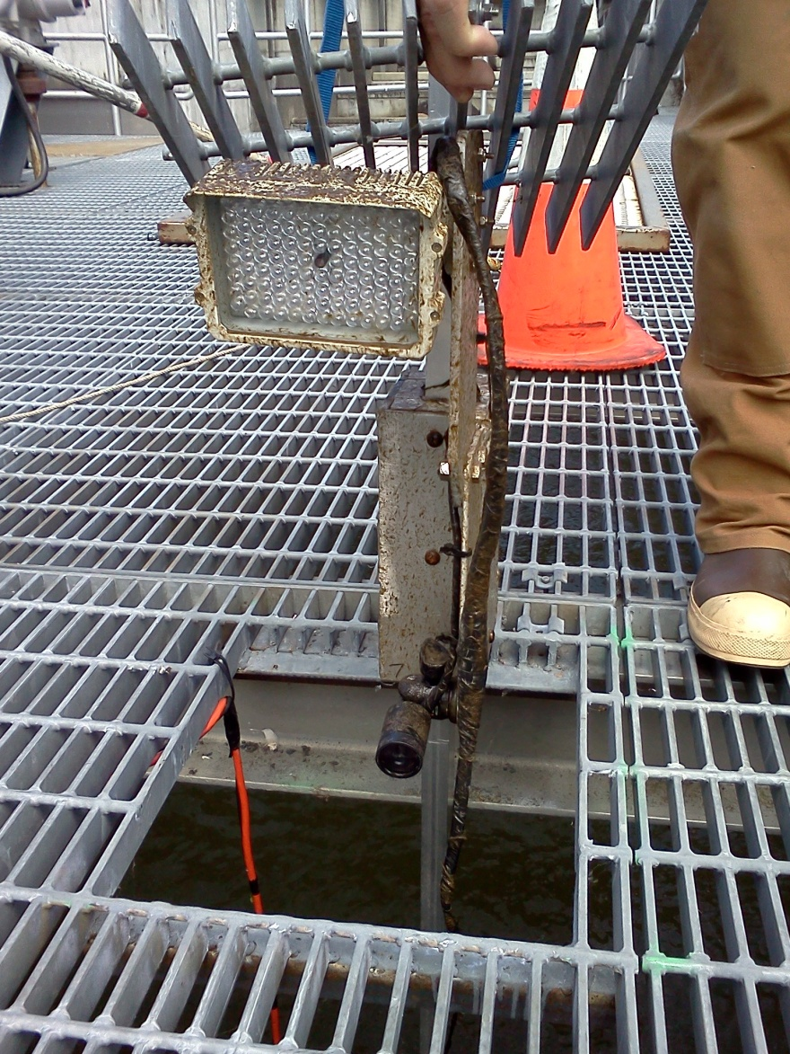
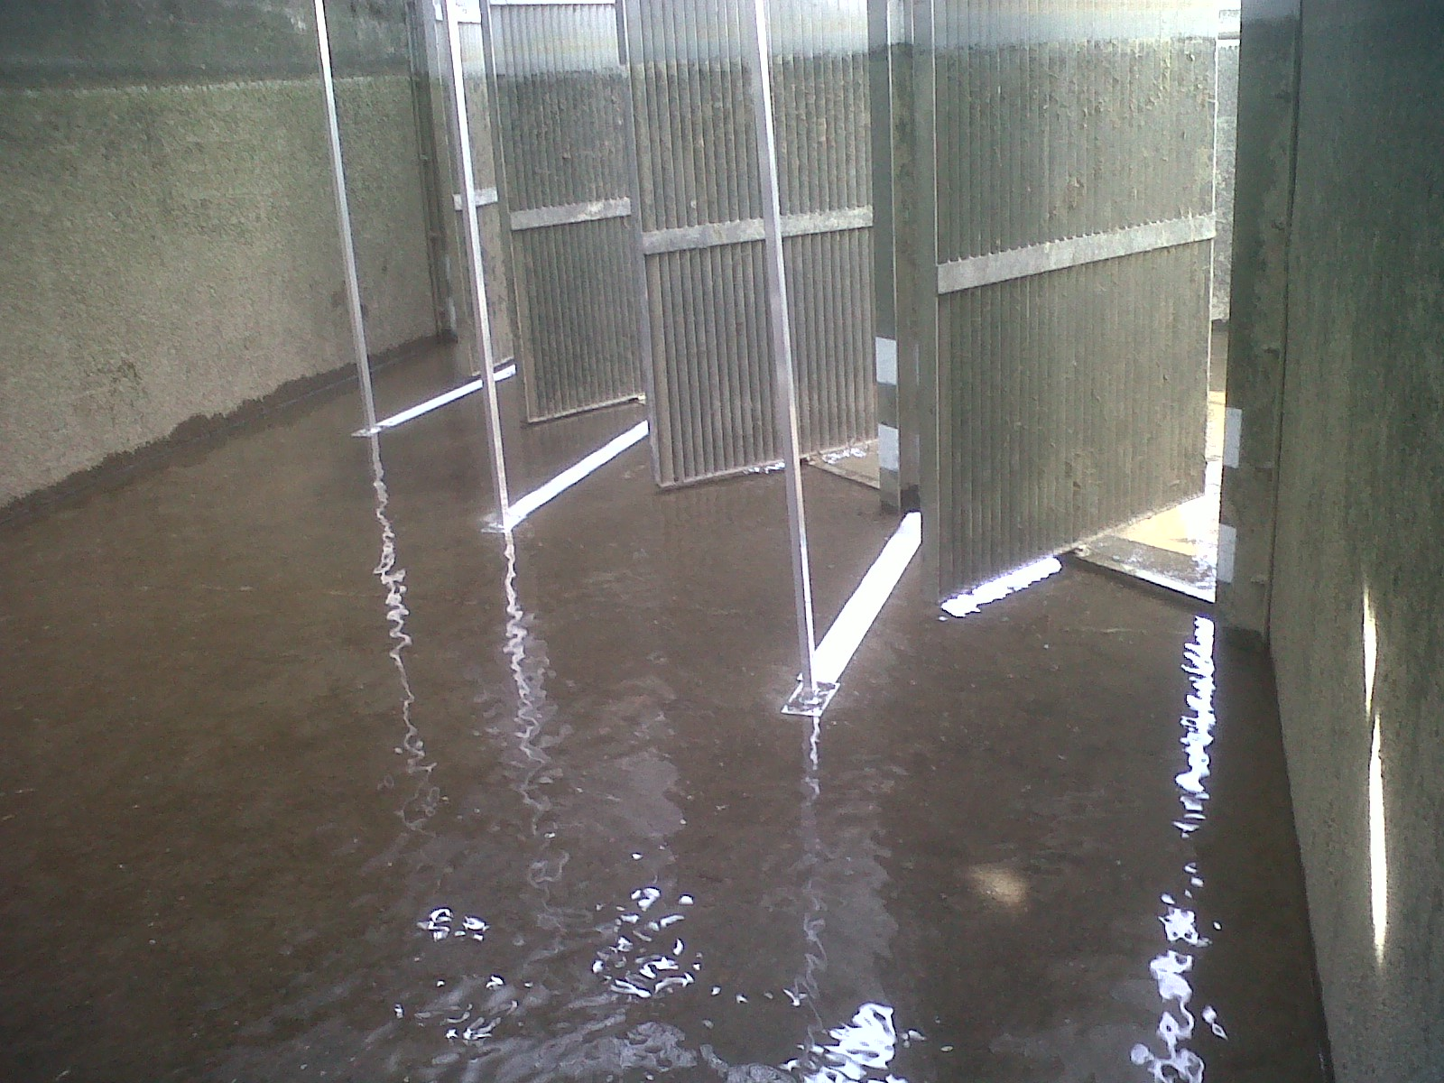
Mounting posts
Camera shuttle
used in 2011
Shuttle proposed for use
in 2012 in fishways
Infrared
lamp
Camera

Figure 1. Camera mount posts (left), camera shuttle used in 2011 (center) and drawing of camera shuttle proposed to be used in fishways in 2012.

Figure 2. Drawing of proposed DIDSON mount and
shuttle for use in The Dalles North Fishway.

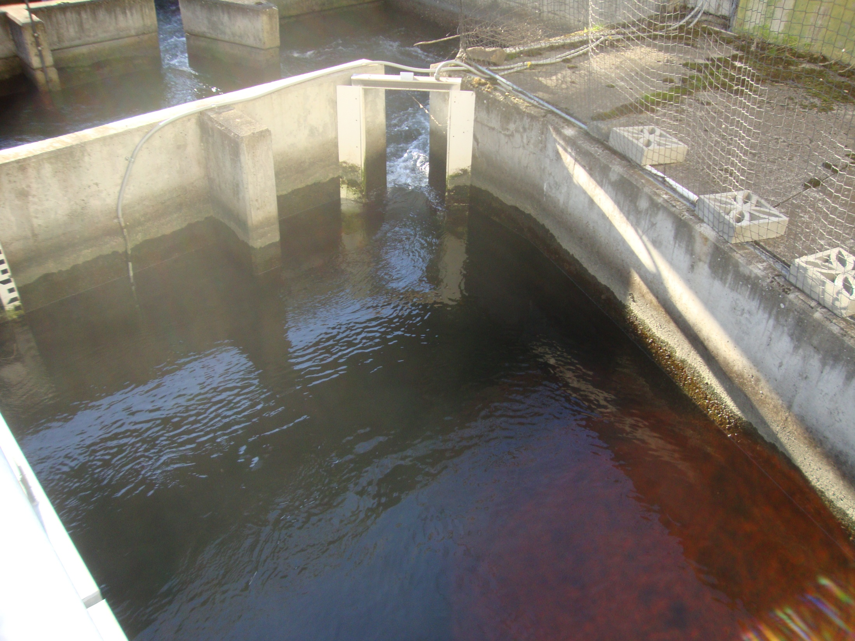
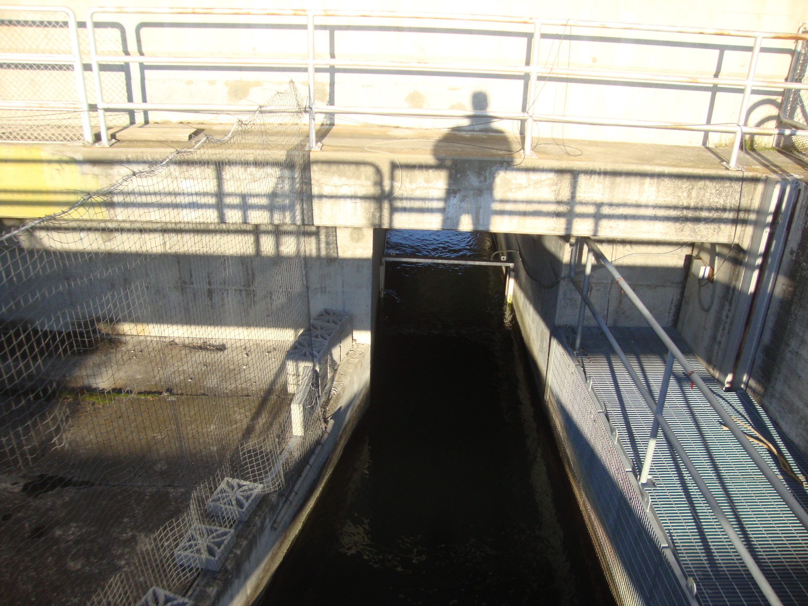
Figure 3. Top view drawing of pool upstream of the last vertical slot weir near exit of The Dalles Dam North Fishway, showing locations for video camera and DIDSON mounts (right) and phot inserts looking downstream (top left) and upstream (bottom left) at this location.
Overhead walkway
Didson
Video
Flow
Video

